Dear __________(insert patient’s name),
Welcome to the SIVUH,
Hospital Admission can be a stressful event in people’s lives increased currently by the Covid-19 pandemic and visiting restrictions.
We want to help you stay connected with family and close friends during your stay, and keep them informed on your progress.
Staying connected will help your recovery and mental health!
How we can help to Promote Family Communication
- Tablets are readily available for you to use on the ward for family video calls
- If you do not have a mobile phone you can use the ward telephone.
- Your family can email messages to Cronin.valerie@sivuh.ie which will be printed for you.
- A time can be arranged for your family to discuss your care with nursing staff
YOU TELL US:
1.Do you normally use: (Please tick all that apply)
Landline/Telephone (voice-calls)
Mobile phone(voice-calls)
Mobile phone(text messages)
Video-calls, (Skype/facetime/whatsapp video/zoom)
Other (please specify)

2.Do you need access to a communication device while in hospital? If yes a device is readily available to you.
3. How can we help? Please inform nursing staff of any way we can help you to communicate better with you family.
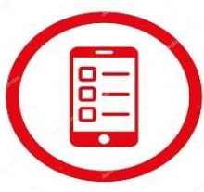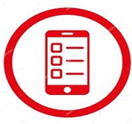
For more information log on to: https://www.sivuh.ie/

